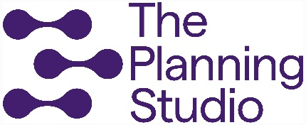

Social Inclusion
Discussion Paper
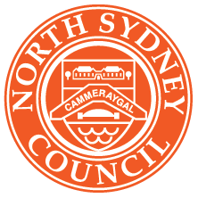
North Sydney’s next ten years - Have your say
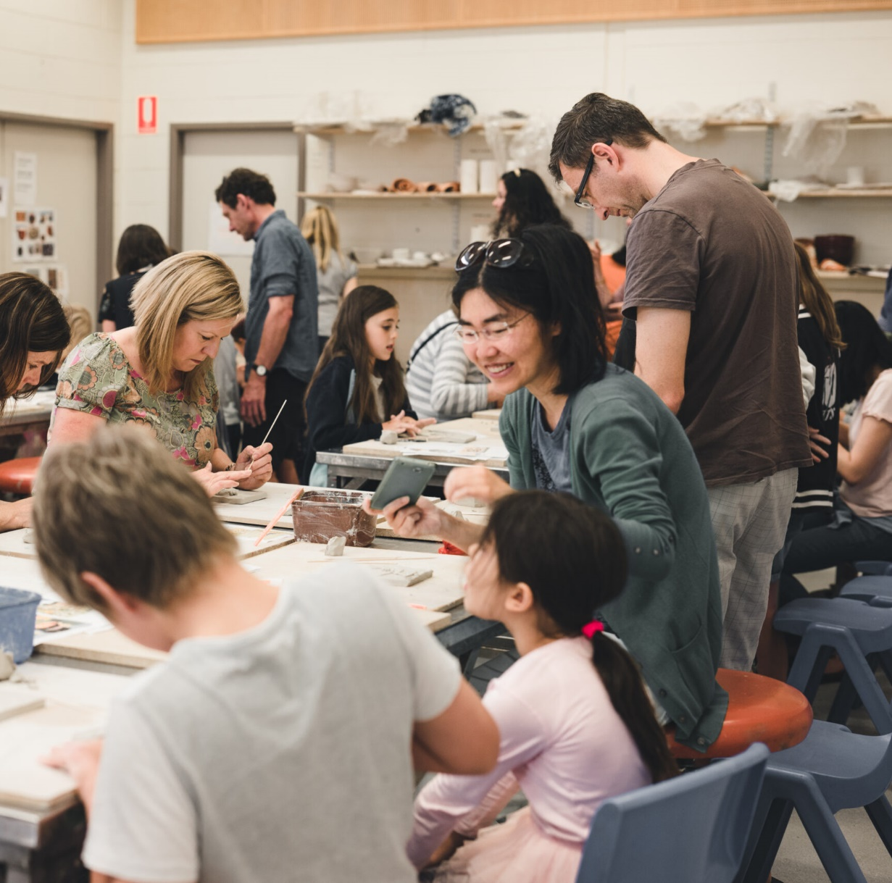
Contents
Recognition of the Cammeraygal People 3
Purpose of this paper 4
What do we mean by social inclusion? 7
About North Sydney 10
Social inclusion in North Sydney 12
Focus areas to guide discussion 14
1. How we maintain CONNECTION with each other 16
2. How we nurture BELONGING within our community 19
3. How we encourage and value our community’s CONTRIBUTION 22
4. How we continue INVESTING to build social inclusion 25
Next steps 28

Recognition of the Cammeraygal People
We respectfully acknowledge the Traditional Custodians of the land and waters of North Sydney local government area (LGA), the Cammeraygal people.
We recognise the Cammeraygal people as the Traditional Owners of the area known today as North Sydney. We acknowledge that the alienation of Cammeraygal Country occurred with a land grant in 1794 without consultation, treaty, or compensation.
Western archaeological evidence shows that Aboriginal people have been in North Sydney at least 5,800 years, and likely for thousands more. We treasure and seek to preserve Cammeraygal connection to Country.
In 1890, when North Sydney Council was formed through the merging of three boroughs, the word Cammeraygal was included on its coat of arms. Today it holds a central position in the Council’s logo as a reminder of the long and ongoing Indigenous heritage of this place.
In recent years the spelling of Cammeraygal has varied to include Gammeraigal and Gai-maragal as our community has sought to reflect and honour the heritage of First Nations people in a more culturally appropriate manner.

Purpose of this paper
The purpose of this discussion paper is to present information to guide comprehensive engagement regarding social inclusion in North Sydney. It highlights some of the strengths, challenges and strategic opportunities within our LGA and encourages thought on where we are now, where we want to be and how we will get there.
The information collected through the consultation will help identify the needs and aspirations of North Sydney over the next ten years and will be used to develop our Social Inclusion Strategy.
The Social Inclusion Strategy is one of eight informing strategies that together will consider needs and priorities in the following key areas:
- Culture and Creativity
- Economic Development
- Environment
- Governance
- Housing
- Integrated Transport
- Open Space and Recreation
- Social Inclusion
Once prepared, these eight Informing Strategies will be combined to form our new 2025-2035 Community Strategic Plan, Delivery Programs and Operational Plans. They will determine our priorities and ensure that Council’s resources are focused on delivering outcomes needed and wanted by our community.
North Sydney is a welcoming, connected and resourceful community that acknowledges its past, enjoys the present and plans for the future. We respect our beautiful harbourside locale, its unique villages and much valued bushland and open spaces. We lead the way in sustainability”.
- the Community vision

We are committed to being a welcoming and connected community
As a Council, we recognise that social inclusion – in our community, work, and decision-making – is fundamental to the wellbeing of our community.
This discussion paper provides a framework within which we can work collaboratively with the community and stakeholders to develop a clear and shared understanding and vision for social inclusion.
It also serves to acknowledge the strengths of our existing community organisations, groups, services and spaces, as well as ensuring a strategic and coordinated approach, to build a welcoming and connected community where everyone is able to freely access, participate in and contribute to community life.
These commitments will be the basis of the Social Inclusion Study and will continue to inform our plans, services, events, spaces, infrastructure and programs, as well decision-making across Council.

The role of Council
North Sydney Council is concerned with the full range of issues impacting our community, however we acknowledge the limitations of what we can control or influence. Depending on the particular activity, our role can be:
- Advocacy: using our knowledge, priorities and partnerships to advocate for our community to other levels of government and the private sector
- Delivery: infrastructure, services, events and resources
- Connection: connecting our community to the services, resources and support they need
- Governance: working in collaboration with and partnership to develop plans and further the community’s aspirations.
Part of the purpose of the discussion paper is to consider our role, responsibilities and priorities in relation to other levels of government, as well as our communities and commercial organisations.
We are committed to social inclusion and improving our community’s access to the support they need, and their connections to each other. We want to invite participation and engagement from everyone in our community, and for them to know that their contribution is valued and vital to a socially inclusive North Sydney.

Questions for you to consider
Throughout this Discussion Paper, you will be asked to consider a series of questions. These questions have emerged from our research and are a starting point for discussion to inform the preparation of the Social Inclusion Strategy.
- In what ways do you feel connected to your community?
- How can we build stronger connections between different groups and people?
- What does belonging mean to you?
- What space, activities, ideas and methods do you think would invite everyone in our community to feel more connected and that they belong?
- What are some of the barriers to people participating in the civic life of North Sydney LGA?
- In what ways to you think we can better engage with our community?
- What role can the community and business play in nurturing a socially inclusive North Sydney?

What do we mean by social inclusion?
As a community, we have achieved significant social progress in recent decades and we recognise that everyone’s experience, needs and expectations are unique. Because of this, social inclusion is both multi-dimensional and context specific.

Defining social inclusion
The United Nations defines social inclusion as “the process of improving the terms of participation in society through enhancing opportunities, access to resources, voice, and respect for rights”.¹ For the Social Inclusion Study, we define social inclusion as being:
“When everyone in our community - no matter their background, economic status or personal circumstances - feels welcome to be themselves, is connected to others, and can freely access the services, programs, places and resources they need to participate, contribute and reach their potential”.
In defining social inclusion, we have also sought to use the established UN Sustainable Development Goals (SDGs) Framework as a guide to ensure a best practice approach is used in the development of the Strategy.
The collection of 17 goals and 169 targets set by the United Nations aims to enable societies, economies and the environment to develop and thrive, to ensure no one is left behind.
Social and community infrastructure is a core enabler to achieving the SDGs. It provides the basic systems, structures and services that are essential to enabling society to function and prosper. The figure opposite summarises the goals that directly relate to social inclusion.

Social inclusion principles
Inclusivity is one of the principles of the North Sydney Vision 2040 Community Strategic Plan. This means we value our individual differences - whether they relate to age, ability, income or background - and embrace the diversity of our community and their culture, ethnicity, gender, sexual orientation and beliefs.
We know that an inclusive, diverse North Sydney is stronger, more resilient and a place where people want to live, work and visit.
The following principles have emerged from the research. As part of the engagement conversations, we will further refine them to guide the Social Inclusion Strategy.
- Our individual differences are part of our collective strength and success.
- All community members have the right and access to participate freely in community life.
- Our community is connected, and can contribute and ask for help.
- Partnerships with our community, local organisations and institutions optimise the delivery of our services, programs and infrastructure.

UN Sustainable Development Goals
The UN Sustainable Development Goals is an established framework with specific targets. The identified goals are relevant to the North Sydney Social Inclusion Study
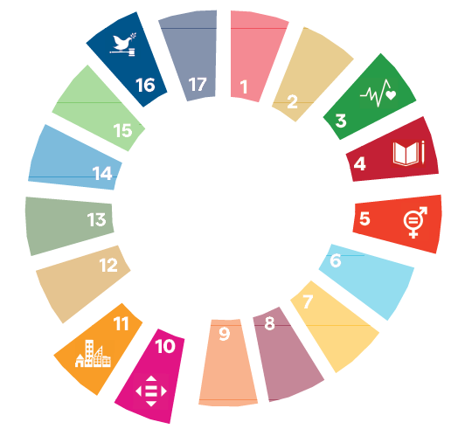

Good Health & Wellbeing
We are seeking to explore what we have and what is needed to support our community so everyone can lead a physcially, socially and mentally healthy life.

Quality Education
We are seeking to explore the learning opportunities availiable to everyone at all life stages to support understanding, informed decision-making and valued contribution to our community.

Gender Equality
We are seeking to explore interconnections across our community and understand inequalities that may exist, whether they relate to access to services or disconnection of specific cohorts.

Reduced Inequalities
We are seeking to explore opportunities for all girls, women and gender-diverse people to freely participate and have a voice in our community.

Sustainable Cities & Communities
We are seeking to understand the social network of places, people and spaces that are the foundation of a safe, sustainable city and social captial so everyone can reach their potential.

Peace, Justice & Strong Institutions
We are seeking to identify elements of inclusive governance and understanding many partnership opportunities between Council and the community, business and local groups.

About North Sydney
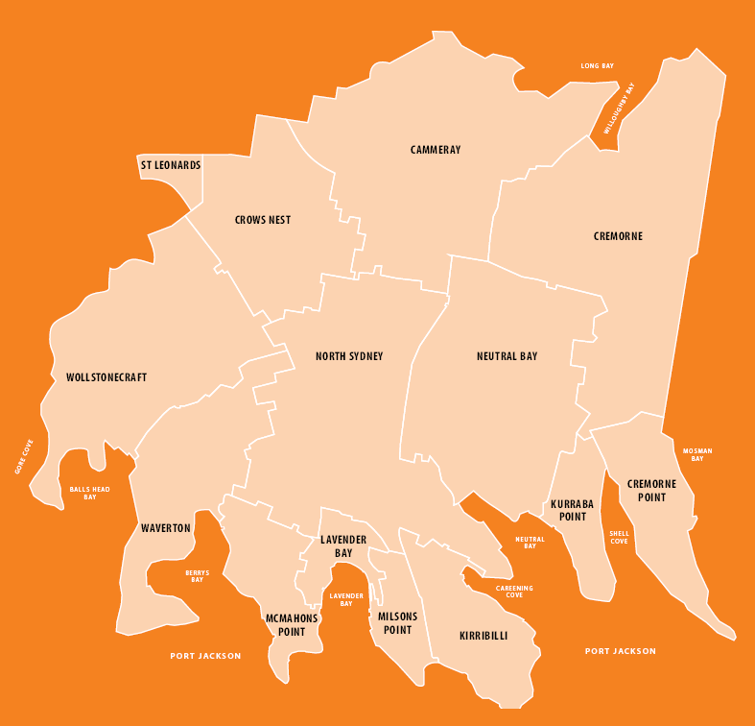
- St Leonards
- Cammeray
- Crows Nest
- Cremorne
- Wollstonecraft
- North Sydney
- Neutral Bay
- Waverton
- McMahons Point
- Lavendar Bay
- Milsons Pint
- Kirribilli
- Kurraba Point
- Cremorne Point

Our community
- 72,014 people - Estimated resident population (2023)
- 79,442 people in North Sydney LGA - Forecast population (2036)
- 0.4% First Nations Peoples - 1.2% Greater Sydney (2022)
- 38 yrs median age - 37 yrs Greater Sydney (2022)
- 16.7% aged 65+yrs (up 18% since 2016) - 14.7% Greater Sydney (2022)
- 29.5% aged 30-44yrs (down 8.8% since 2016) - 23% Greater Sydney (2022)
- 37% single households (up 5% since 2016) - 22% Greater Sydney (2022)
- 54% couples no children - 34.5% Greater Sydney (2022)
- 77.3% of dwellings are flats - 35% Greater Sydney (2022)
- 52.3% of dwellings are rented - 39.6% Greater Sydney (2022)
- $2,526 median household income - $2,099 Greater Sydney (2022)
- 1.4% social housing - 4.1% Greater Sydney (2022)
- 2.5% of people need help due to disability - 5.3% Greater Sydney (2022)
- 9.8% of people are engaged in unpaid assistance - 11.2% Greater Sydney (2022)
- 17.7% of people do voluntary work - 12.3% Greater Sydney (2022)
- 40% born overseas - 39% Greater Sydney (2022)

Social inclusion in North Sydney
The North Sydney community offers a variety of skills and knowledge that contribute to our collective resilience, wellbeing and sense of belonging.
This summary outlines the many places, spaces, programs and services already provided across our area that support and inspire our community. This baseline will enable us to have an informed discussion about future needs and priorities to support social inclusion.
The Discussion Paper does not seek to examine social inclusion through a single lens, but rather to understand where we are right now, and to identify our strengths, challenges and opportunities.
We acknowledge that our background, circumstances and personal characteristics mean that challenges and opportunities are experienced very differently across our community. It is for this reason that discussions within the broader community are vital to the success of the Social Inclusion Strategy.
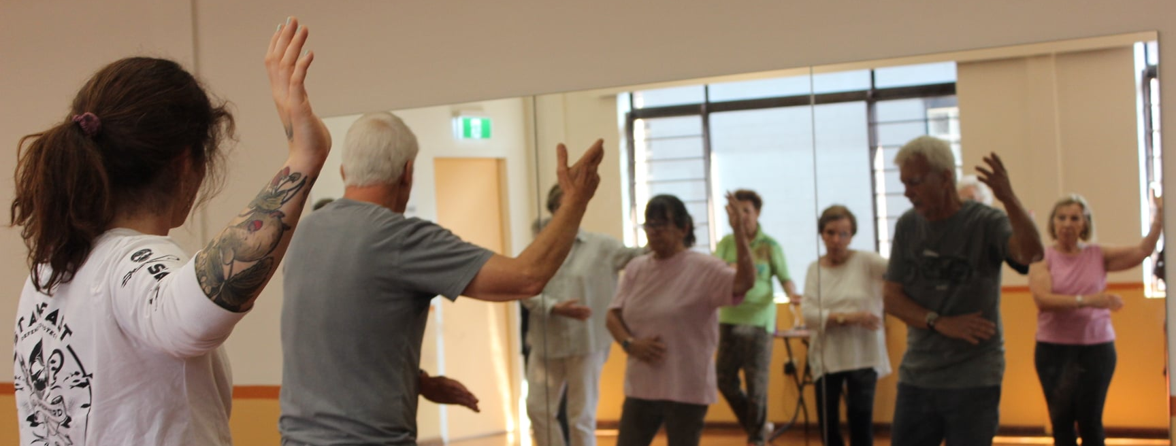

Everything starts with Country
Australia’s First Nations Peoples are the custodians of the world’s oldest living cultures. For more than 65,000 years, Australia’s Aboriginal and Torres Strait Islander Peoples developed, implemented and maintained sophisticated systems of culture, language, environmental protection, social life and spirituality.
The land on which the North Sydney LGA is located, the north shore of Sydney, was inhabited by the Cammeraygal (Gameraigal) clan. Balls Head has some of the most significant remaining Aboriginal sites in North Sydney. The physical evidence of the first inhabitants of the north shore can be found in fire-charred caves, stencilled hands painted on stone, engravings of animals and weapons on rocks, and middens of whitened seashells from thousands of meals.³
Existing suburb and place names around the North Sydney LGA reflect the history and importance of First Nations Peoples to the contemporary place, such as Cammeray (from the Cammeraygal clan); Kirribilli (from the Aboriginal word ‘Kiarabilli’ meaning a ‘good fishing spot’); Warungareeyah
(the Aboriginal name for Blues Point); and Gooweebahree (the Aboriginal name for Lavender Bay, originally recorded as Quiberee, meaning
‘a spring of fresh water’.)

What infrastructure, services and programs do we have to support social inclusion?
Community facilities, spaces, programs, services and networks support our communities to be happy, safe and healthy; to learn; and to enjoy life.
A network of social and community assets is critical to unlocking the inherent value, skills, connections and knowledge that exist within the North Sydney LGA. The map (page14) illustrates the type and distribution of community infrastructure and assets that exist across the North Sydney LGA. The map does not include arts and cultural facilities or parks and open spaces as these are being considered as part of concurrent studies.
The distribution of community infrastructure, services and programs across the LGA is relatively even. Through the community engagement we will further explore the accessibility and experience of these facilities and services, and whether they respond to the needs of our growing community.
Social housing in the North Sydney LGA is 1.4% of total housing stock. In general, housing across the North Sydney LGA is classified as being unaffordable and there is a lack of housing options across the price spectrum, particularly for key workers (such as teachers, nurses and firefighters) and low-income households.
Therefore, housing affordability will continue to be a significant issue within the LGA, particularly for very low to medium income households as well as key workers, single parent families and those on pensions, who are likely to be more acutely impacted.
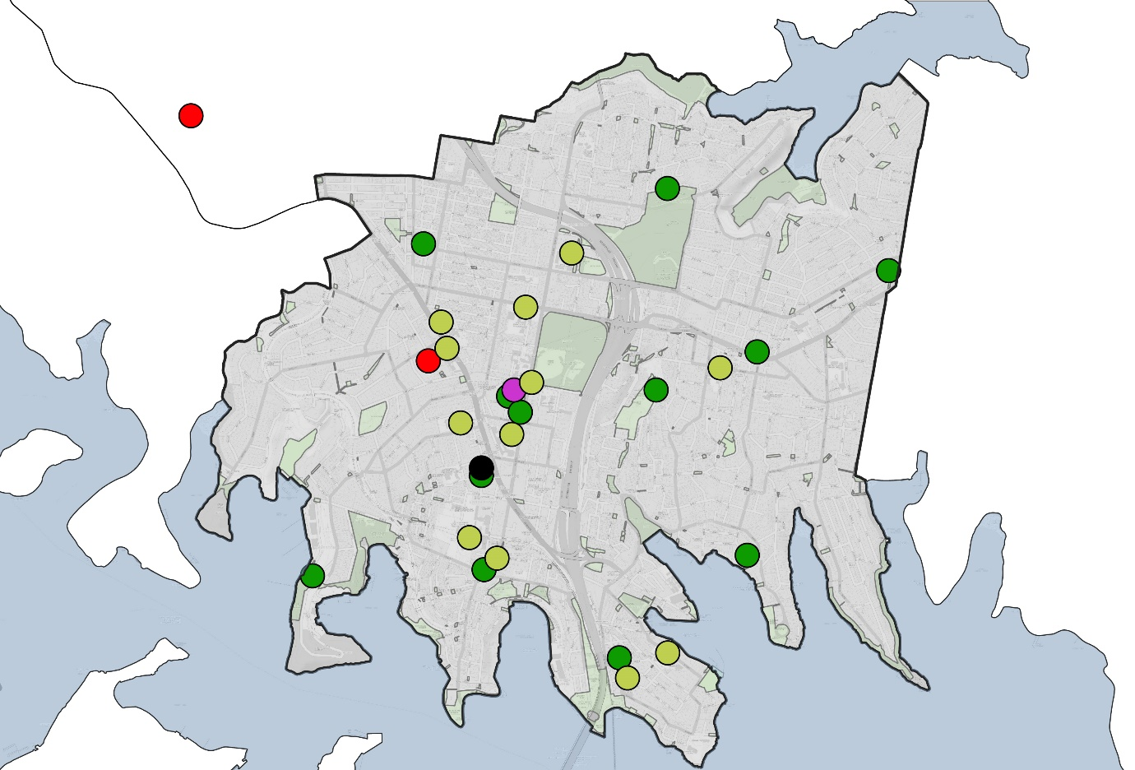
- 10 Community centres and halls
- 1 Library
- 2 Hospitals (1 outside the LGA - Royal North Shore)
- 15+ Schools and tertiary education
- 13+ Cultural spaces (as per the Culture and Creativity Study)
- 169Ha Public open space (as per the Open Space and Recreation Study)

Focus areas to guide discussion
This paper proposes four areas of focus to guide conversations with our community to identify the infrastructure, services, programs, advocacy and actions to support the future priorities.
The four focus areas provide a common language and understanding. They are an interconnected framework to consider social inclusion through an objectives-based approach. This acknowledges that each individual and community group, or cohort, will have a unique perspective and expectation.
We will seek to identify individuals and groups who may be unintentionally ‘invisible’; underrepresented; or experiencing barriers to accessing, contributing and participating in the community life of North Sydney.
Within this context, we acknowledge that some people will likely require more dedicated support, and the four focus areas will have varying relevance to each person. Establishing a common understanding and language will enable us to consider our collective needs and aspirations.
We want our community and stakeholders to consider what the key priorities are to address our highest needs and achieve our aspirations. This will ensure that the North Sydney Social Inclusion Strategy provides a roadmap for how Council and the community can work together, including strategic partnerships and measurable indicators to evaluate success.
Investing for the highest impact will increase our community’s connection to each other and Council. This connection fosters a deep sense of belonging – critical to inclusion – and creative opportunities for our community to be aware of, participate in and contribute to civic life.
The below 4 areas work in a cycle

Connection
Prioritised investment will foster strong community connections to support the social, cultural, economic and political health and vitality of our community.

Belonging
A connected community provides opportunities for our community to be seen, heard and – crucially – accepted in ways that are meaningful to them.

Contribution
An inclusive and connected acommunity can access, contribute to and fully participate in civic life, where differing voices and experiences are valued.

Investment
Leveraging our investment – both human and financial – through collaboration, partnerships and innovation to unlock our true potential and optimise our impact.

How we maintain CONNECTION with each other

What is connection about?
Increased social connections within and across communities have a positive impact on their social, cultural, economic and political health and vitality. Reducing social isolation, ensuring opportunities for participation and welcoming the contribution of all individuals are key pillars of a connected community. North Sydney Council plays a strategic and proactive role in fostering opportunities for rich social connections within and across the community.

Children and young people told us that they wish North Sydney would ...
- “be more interconnected .. work with other areas to bring us all together”
- “Create more ways that allow people to be with people with the same interests”
- “host events and activities that foster a greater connection and belonging in
the community”
- “have more parks and community centres for public interactions with one another”
- “have community centres where people meet other members of the community”
- “be a place that creates connections between schools and small businesses”

Example to Learn from: Humanitas - Intergenerational Living, The Netherlands
In 2012, the Dutch government stopped funding care costs for citizens over the age of 80 without an urgent care need. As a result, many people living in long-term care facilities were lonely, isolated, focused on their limitations and unhappy. At the same time, student housing was expensive and limited.
Humanitas, a home for the elderly, created an intergenerational living environment consisting of six students and 160 elderly residents.
The governance model focuses on the everyday lives of all residents. It is not only an environment in which elderly people live, it is now a central place in the community where elderly people, students and others in need of support live together, and the broader community enjoys spending time together well.

Connection - Issues and opportunities
Socially connected communities are more likely to experience reduced levels of mental illness and cognitive decline, achieve a healthy work life balance, succeed at school and work, and be part of safer communities. More than one quarter of Australians are lonely, and most Australians will experience loneliness in their lifetime, with higher rates among young people and the elderly.
Opportunities for intergenerational connection have been shown to improve cognitive function, increase empathy, and promote people living longer.
In collaboration with the community we are seeking to identify where our social connections are strong and well established, and where they are diminishing or have disconnected.

Let’s discuss connection
- While young people are more connected than ever, loneliness and social isolation are increasing, particularly in people aged 15-24. The population of North Sydney is ageing and we know that for older people, the risk of experiencing loneliness and social isolation is signficantly higher than for other age groups.
With one person households making up nearly 40% of all households in North Sydney, combined with the ageing population, there is a significant risk of increased social isolation and loneliness.
  - What actions can we take to minimise social isolation and loneliness?
  - How can we increase opportunities for intergenerational connections? (for example, connections with schools and the broader community)
- 45.5% of our residents lived somewhere else five years ago and 52% of all dwellings are rented. The transient nature of our community also increases the risk of social isolation and may result in people feeling less connected to the community.
  - In what ways do you feel connected to your community?
  - How aware are you of spaces, places and groups across the North Sydney LGA that enable you to connect with others?
- Our social networks are both formal and informal. While the frequency and level of connection may differ, it is the quality of these networks – the depth, strength and diversity of our connections – that is critically important.
  - What currently supports our community to feel more connected? (think about the spaces, activities and ideas)

How we nurture BELONGING within our community

What is Belonging about?
Belonging is not only our connectedness to our community, it is the sense that we are welcome, that we can be part of something and that we are truly accepted. Belonging is tied to our identities, through our shared beliefs, values or ideals and in acceptance of our different experiences, circumstances and aspirations.
To belong is to know that there are a variety of options, opportunities and experiences that enable us to engage with community life, should we choose to. While North Sydney, compared with the rest of Sydney, has a relatively low mix of economically, culturally and socially diverse communities, we are committed to fostering a community where all people feel welcome, and share a strong sense of belonging.
- 45% of our residents have lived in the LGA for less than 5 years
- 0.4% First Nations Peoples
- 40% born overseas
  - 6.6% England
  - 3.8% China
  - 2.7% New Zealand
  - 2.4% India
- 3% LGBTIQA+ couples

Children and young people told us that to them belonging means ...
- “Listening and learning together”
- “Trust by family and friends”
- “Accepting who other people are”
- “People just smiling and acknowledging you”
- “Helping each other - like baking someone a cake”
- “Have a safe space for your ideas”
- “Sharing similar experiences and common interests - opportunity to do stuff with local community”
- “Not being afraid to speak out”
- “Being involved”
- “Cultural inclusion and recognition”
- “Having a sense of identity

Belonging - Issues and opportunities
Belonging means different things to different people. For some, it can be simply feeling welcome and knowing their neighbours, while for others, it can be
a much deeper level of engagement with their community and civic life.
It is vital that we provide a variety of opportunities for our community to ‘belong’ in their own way. Community members who feel a strong sense of belonging are
2.6 times more likely to report being in excellent health than people without a sense of belonging.
In Council’s 2023 Customer Satisfaction Survey, more than half (64%) of participants agreed North Sydney has a strong sense of community. However, this has declined approximately 11% (from 75%) since 2020. The sense of community of people aged 50-59 years is also significantly less than the average at 53%.
Belonging to a community is also feeling that you can ask for and access the help and support you need. With a lower population of economically, culturally and socially diverse communities, the ongoing viability of critical social services could be at risk. This could devastate our most vulnerable community members.

Let’s discuss belonging
- When community members are socially connected through networks, services and places, and, have opportunities to engage and participate we foster a community where people feel they belong.
  - What does belonging mean to you?
  - What makes you feel you belong? (think about the spaces, places, facilities, groups and activities)
- It is vital that we engage with all parts of our community to ensure they have free and equitable access to our community spaces, information and services available. In particular, vulnerable groups can be excluded from physically accessing buildings, or accessing information due to a reliance on digital media channels or language barriers.
  - In what ways do you think we can improve accessibility for everyone in our community?
- The number of households on higher incomes has increased, the number on lower incomes has decreased, and the cultural and age diversity of our community is less than other areas across Greater Sydney. Sharing our experiences, stories and traditions allows us to feel part of something bigger and that we are contributing to a North Sydney community that welcomes people of different backgrounds, ages, abilities and circumstances.
  - Why do you think our community’s sense of connection has decreased?

How we encourage and value our community’s CONTRIBUTION

What is Contribution about?
An inclusive and connected community is better able to contribute to and fully participate in civic life. North Sydney Council values diverse voices from across our community, and seeks to provide opportunities for our community to be highly engaged.
We welcome our community’s perspectives and seek to understand their needs and aspirations. This understanding strengthens our decision-making and guides our investment in building the capacity and resilience of our community.

Example to Learn from:
Sydney Policy Lab, Civic Engagement Index
Released in 2021, the University of Sydney’s Civic Engagement Index explores how Australians connect to their communities. The Index scores individuals based on their levels of trust, participation and connection with other members of their community. The findings include:
- Younger people who grew up in a home where English is not the primary language spoken emerged as the most engaged citizens
- People who were older, poorer and lived in rural areas rated significantly lower when it came to civic engagement
- People with children rated significantly higher on civic engagement than people without children, suggesting family draws people into civic spaces

Children and young people told us that their voice matters because they ...
- “should know the processes and be integrated into future processes”
- “challenge the norm”
- “offer new perspectives”
- “are dealing with problems that other generations created”
- “bend the rules”
- “[have] big imaginations
- “are NOT boring”
- “take risks and aren’t afraid of things”
- “might see things adults may not, like a broken slide”
- “[worry that] things stay the same if we are not listened to”

Contribution - Issues and opportunities
As the branch of government most connected to local communities, and to reflect good governance, we recognise that providing a formal framework and opportunities for open dialogue and meaningful participation will strengthen Council’s engagement with our community, and our community’s engagement with each other.
Participation in civic life builds social capital, which increases the capacity and resilience of the community to identify and address challenges and change.
Civic contributions can be made through voting, activism, volunteering and engagement in community activities and organisations. With a highly educated, wealthier and older community mix, there is likely to be untapped capacity in our community to increase participation and contribution.
We need to ensure our community is aware of and can identify opportunities to lead or advocate for change, and to work with Council, relevant agencies and local organisations in a proactive and constructive way.

Let’s discuss contribution
- Our community’s participation and involvement in civic life is essential to our future. It also helps Council to understand the needs and aspirations of our community, which then flow through to our work, our decisions, how we direct investment and our advocacy efforts.
  - In what new ways can we effectively engage with our changing community?
- Nearly 18% of North Sydney LGA residents are volunteers, larger than the share for Greater Sydney. However, with an ageing population, increasing number of young families, and increased cost of living, the need for volunteers is likely to grow.
  - How can we better connect our community with the range of existing volunteering opportunities, and identify new ones?
- To ensure we provide the appropriate opportunities, we need to identify where there are barriers to participation and contribution. With a lower population of economically, culturally and socially diverse communities, the risk is that some people become ‘invisible’ or do not have the opportunity for their voice to be heard.
  - What would make you and your neighbours feel welcome to participate in civic life?

How we continue INVESTING to build social inclusion

What is investing about?
Council is best placed to understand social issues within our community, however with increasing expectations on local government and limited resources, we are aware of our capacity and resource constraints and aim to maximise our impact.

We will seek to collaborate and partner across all levels of government, service providers, community organisations and other local councils to maximise our resources, share knowledge and coordinate activities.

Example to Learn from:
Democracy Garage, Copenhagen
Demokrati Garage (Democracy Garage) is located in the North West area of Copenhagen and is the city’s democracy house and a meeting place for participation. Formerly a blacksmith and car workshop, this space is now a DIY workshop encouraging more and better democracy.
It functions as a meeting place for democracy innovation and everyday participation or ‘Demokrati Fitness’. The Garage also is home to:
- Flere Fugle: Copehagen’s first citizen bakery
- We Do Democracy: democracy advisors who develop and implement new democratic and partipatory formats
- SAGA: party-neutral youth organisation with over 1000 members, teaching younger generations that democratic society and using one’s voice has the potential to change the world
- Kontra Advokater: human rights NGO that deals with social, employee and climate law cases
- Folkestuen: community and event space in the converted forge
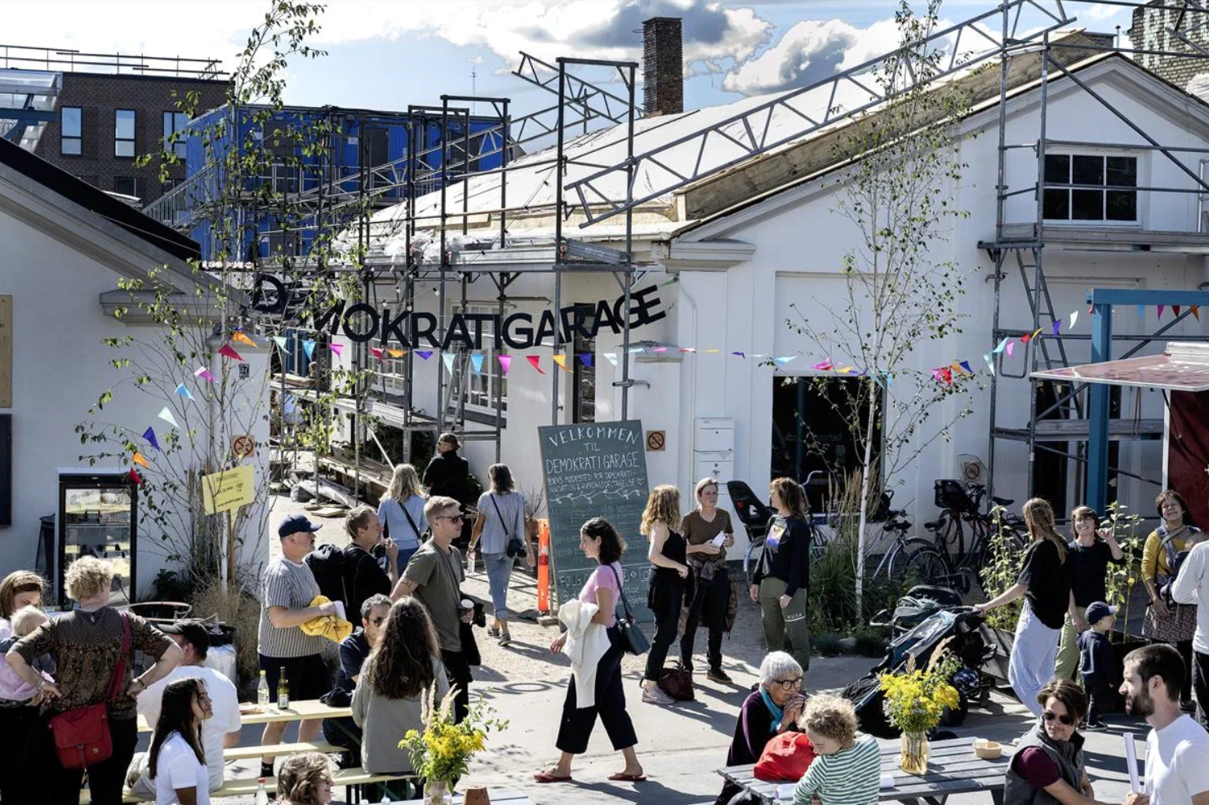

Investing - Issues and opportunities
North Sydney Council has a significant role in the planning, delivery and management of community infrastructure. We also support, coordinate and advocate for services where gaps exist, to ensure an equitable distribution of services and support.
This includes providing inclusive access to Council’s programs, resources, services, spaces and infrastructure. We also work with community organisations, local business, industry, education providers and other service providers to ensure an integrated, evidence-based, local response to our community’s priorities and aspirations.
As noted earlier in the paper, while Council is concerned with the full range of matters impacting our community, there are many services that support social inclusion that are not in our direct control.
We will continue to work closely with state and federal government to support our community’s access to services such as health, education, police, emergency management and housing; alongside other social services relevant to our community.
We consider our collaboration with local organisations, government agencies and key stakeholders to be an essential pre-condition to the success of our Social Inclusion Strategy.

Let’s discuss investing
- One of the key priorities of this Discussion Paper is to work collaboratively with the community to prioritise our activities, including for the areas of highest need and greatest potential impact.
  - What do you think should be the priority to grow and nurture a socially inclusive North Sydney?
- To successfully implement our priority actions, we all have a role to play. Council’s roles are varied, but the community and business are also critical in creating a more socially inclusive North Sydney.
  - What do you think is the role of community and business in supporting social inclusion across North Sydney?
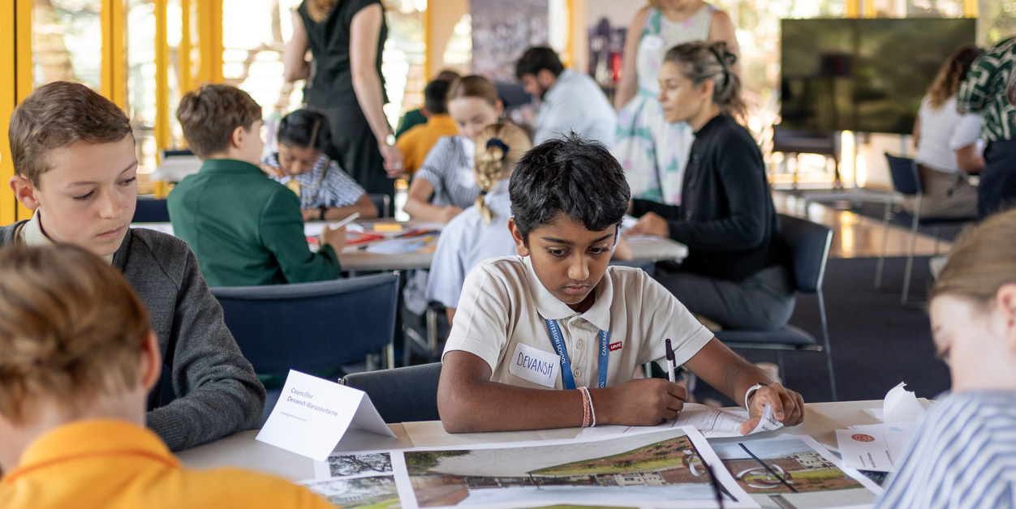

Next steps

How you can participate
We have a number of opportunities for the community to provide their insights and ideas, including:

Complete the online survey
Our 10-minute online survey allows you to contribute your feedback about social inclusion in North Sydney. You can also provide feedback on all strategy topics.

Attend a community forum
Join us for our Social Inclusion Community Forum to hear from expert panelists about how we all have a role to play in social inclusion and join an evidence-based discussion.
Wednesday 15 May | 6pm-7.30pm
Hutley Hall, North Sydney Council

Book into a workshop
You can also book in to be part of our community chats. We will be talking with older people, young people, culturally diverse people, women, people with disability and their carers and the LGBTIQA+ community within the North Sydney LGA.

Have a chat with your Councillors and Council staff
Share your ideas, raise concerns, and tell us what works and what aspects of North Sydney community life you value and want to see more of.
You will find Council staff at local markets and CBD pop-up stalls over the coming weeks, listening to your feedback and answering questions.
For more information about the project or the engagement activities,
visit Have your say on our next ten years
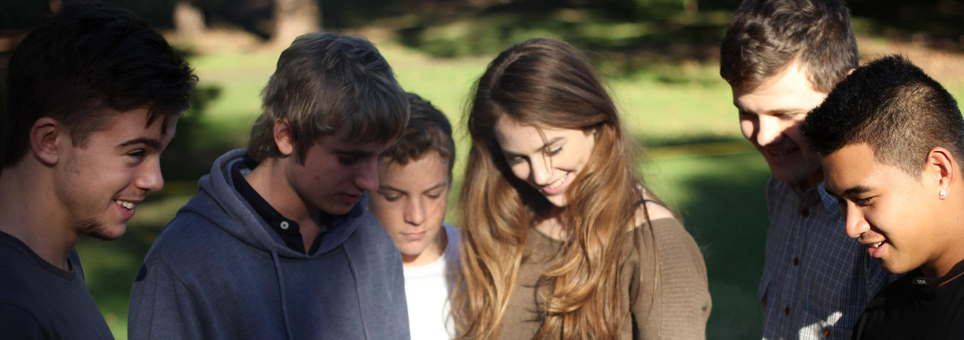

United Nations (2016), Leaving no one behind: the imperative of inclusive development. Report on the World Social Situation
Edmund Rice Centre (2019), Indigenous Resilience Project Report
Hoskins, I (2007), Aboriginal North Sydney: an Outline of Indigenous History. North Sydney Council
Infrastructure Australia (2019), Australian Infrastructure Audit
Samtani, Suraj et al, November 2022, Associations between social connections and cognition: a global collaborative individual participant data meta-analysis, The Lancet, Volume 3, Issue 1
Blake, Martin, 7 August 2023, Connections Matter: A report on the impacts of loneliness in Australia, Groundswell Foundation
Cockrell, Maurya, 19 October 2022, The Power of Intergenerational Connection, American Society on Aging: Generations, Generations Journal, Fall 2022
University of British Columbia, Social Connection and Health, March 2018

